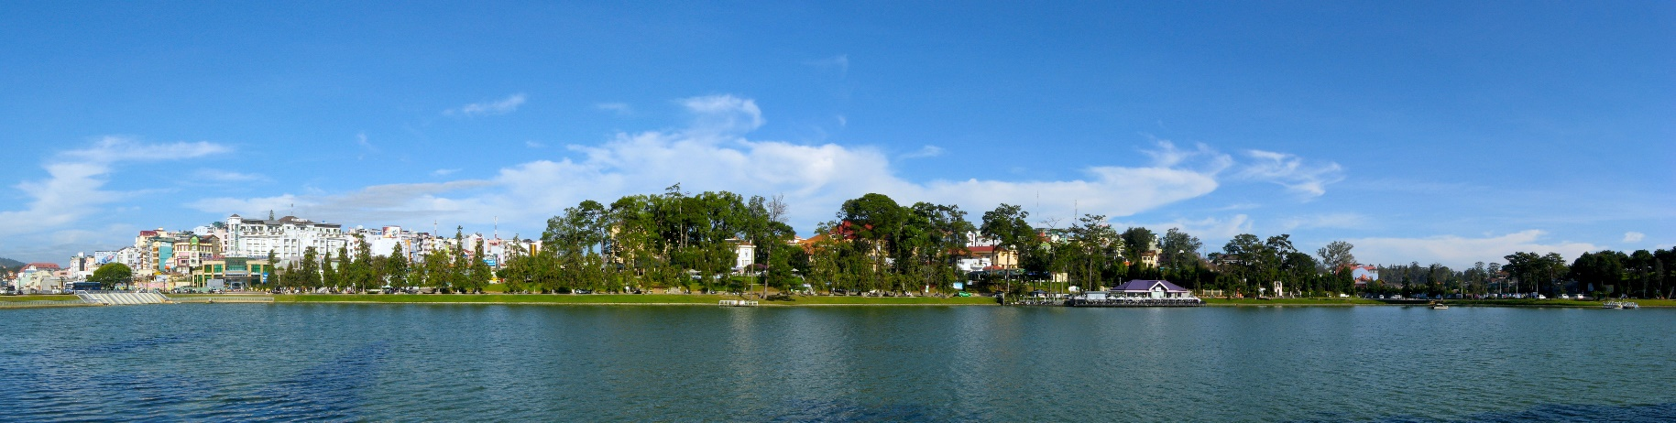
First Announcement and Call for Papers
Vietnam Conference on Nuclear Science and Technology
VINANST-15

August 9th – 11th, 2023, Nha Trang city, Khanh Hoa province, Viet Nam

Dear Colleagues,
Following the success of the 14th Vietnam Conference on Nuclear Science and Technology held in Dalat city in 2021, we are pleased to announce that the 15th Vietnam Conference on Nuclear Science and Technology (VINANST-15) is scheduled to take place in Nha Trang city on August 9th – 11th, 2023. The conference will be organized by the Vietnam Atomic Energy Institute (VINATOM) in collaboration with the Department of Science and Technology of Khanh Hoa Province. VINANST-15 aims to bring together Vietnamese scientists as well as foreign experts, scientists, researchers working in different fields of nuclear science and technology for the exchange of information and presentation of the latest research findings. All individuals, organizations wishing to participate in our conference are kindly requested to register online before March 1st, 2023. In addition to online registration, those interested in delivering their oral or poster presentations at the conference are required to submit an extended abstract before the above deadline. We would greatly appreciate if you could forward this announcement to those who might be keen on attending the VINANST-15.

Best regards,
On behalf of the Organizing Committee
Dr. Tran Chi Thanh, President of VINATOM

Specific Sessions of the conference
  - Session A: Nuclear Power Development and Human Resources Training (Nuclear Power Technology and Design, Reactor Physics, Nuclear Safety, Nuclear Human Resources Development).
  - Session B: Nuclear Physics, Nuclear Data, Accelerators, and Nuclear Analysis.
  - Session C: Radiation Measurement, Radiation Safety, and Environmental Monitoring.
  - Session D1: Applications of Radiation Technology and Nuclear Techniques in Healthcare.
  - Session D2: Applications of Radiation Technology and Nuclear Techniques in Industries and others.
  - Session D3-D4: Applications of Radiation Technology and Nuclear Techniques in Agriculture.
  - Session E: Radiochemistry and Nuclear Chemistry, Nuclear Fuel Cycle, Nuclear Material Science and Technology, Radioactive Waste Management.

Form of the conference
Due to the situation, delegates who are foreign experts, scientists, researchers, or Vietnamese scientists living and working abroad can attend the conference directly or in an online meeting.

Tentative program of the conference
The contributions to VINANST-15 will be considered for the presentation at the plenary or parallel sessions. The plenary session consists mainly of the invited talks, and each parallel session hosts oral and/or poster presentations on a specific topic.
The main language used in the conference is English.

August 9th, 2023:
  - Morning: Opening and Plenary Session (Oral presentations and general discussions)
  - Afternoon: Plenary Session (Continued) and IAEA seminars

August 10th, 2023:
  - Morning: Specific Sessions (Oral presentations).
  - Afternoon: Specific Sessions (Oral and poster presentations), Thematic Seminars/Panels.

August 11th, 2023:
  - Morning: Specific Sessions (Oral presentations);
  - Afternoon: Plenary Session for Conference Summary and Closing.
- Organizing Committee

Head: Dr. Tran Chi Thanh (VINATOM)
Deputy Head: Dr. Pham Quang Minh (VINATOM)
Dr. Hoang Sy Than (VINATOM)
Members:
Assoc. Prof. Dr. Nguyen Nhi Dien (VINATOM)
Dr. Tran Ngoc Toan (VINATOM)
MSc. Bui Dang Hanh (VINATOM)
MS. Le Ngoc Viet (VINATOM)
MS. Nguyen The Vinh (VINATOM)
Dr. Pham Kim Long (VINATOM)
Assoc. Prof. Dr. Pham Duc Khue (INST, VINATOM)
Dr. Nguyen Trong Hung (ITRRE, VINATOM)
Dr. Cao Dong Vu (NRI)
Dr. Dang Quang Thieu (HIC, VINATOM)
Eng. Nguyen Thanh Cuong (VINAGAMMA, VINATOM)
Dr. Phan Viet Cuong (VINATOM)
Eng. Bui Quang Tri (CANTI, VINATOM)
Dr. Ho Manh Dung (CNT, VINATOM)
MS. Dang Thu Hong (NDE, VINATOM)
Dr. Trinh Anh Duc (NTC, VINATOM)
Representatives of Khanh Hoa DOST
Secretariat:
MS. Tran Thi Hong Thai (VINATOM)
MS. Le Thuy Mai (VINATOM)
- Venue and important dates
The VINANST-15 is scheduled to take place in Nha Trang city. The city is one of the most popular tourist destinations in Vietnam.

Important dates:
- March 1st, 2023: Deadline of registration and extended abstract submission.
- May 1st, 2023: Deadline of full-text report submission.
- July 10th, 2023: Notification of the acceptance of the authors’ presentation (oral or poster) at the conference.

Conference fee
- Local participants: 800,000 VND/person;
- Foreign participants: 150 USD/person (applicable to foreign participants attending the Conference directly);
- University student participants are exempted from the conference registration fee.

Sponsors
The Organizing Committee cordially invites organizations, institutions, companies, and individuals to register and sponsor for VINANST-15.
All sponsorships are highly appreciated and will be honored at the conference and accompanied with preferential benefits. The logos of main sponsors will appear on banners, backdrops, and other materials of the conference.

Registration and submission of abstracts
Participants are invited to register and submit an extended abstract to the VINANST-15 Organizing Committee via the conference website: https://vinanst.vinatom.gov.vn/registration-submission.html , no later than May 1st, 2023.

Report format specification:

The extended summary report and full-text report are presented according to the format of the Conference (the report templates will be posted on the Conference's website). Preferentially report in English.

Report presentation at the conference specification:

Oral report presented on PowerPoint.

Poster report presented on A0 paper printed on one side (prepared by delegates).

Conference publications
- Proceedings of the Conference.
- Journal of Nuclear Science and Technology: Several reports will be selected for publication in the Journal of Nuclear Science and Technology (published in English and ISSN 1810-5408) of Vietnam Atomic Energy Society (VAES) and VINATOM. Bonus point (up to 1.0 point) is awarded to authors whose works are published in the above-mentioned journal in their path to professorship or doctorate.

Contact points of the Conference Organizers

Conference e-mail address: vinanst15@vinatom.gov.vn
Conference website: http://vinanst.vinatom.gov.vn
Dr. Hoang Sy Than
Director
Department of R&D Planning and Management, VINATOM E-mail: hsthan@vinatom.gov.vn
Fax: +84-24-39424133; Tel.: +84-24-39412772.
Address: Vietnam Atomic Energy Institute, 59 Ly Thuong Kiet, Ha Noi, Viet Nam.

MSc. Bui Dang Hanh
Acting Director
Department of International Cooperation, VINATOM E-mail: bdhanhnt@gmail.com
Fax: +84-24-39424133; Tel.: +84-24-39424396.
Address: Vietnam Atomic Energy Institute, 59 Ly Thuong Kiet, Ha Noi, Viet Nam.

